***LEY DE KIRCHOFF – Numeric Methods***

Strategy to follow:

* Formulate the system of equations: Analyze the electrical circuit and use Kirchhoff's laws and the relationships between currents and voltages in the components to obtain a system of linear equations. Each equation will represent a constraint in the circuit.
* Write the system of equations in matrix form: Transform the system of equations into matrix form, where you will have a coefficient matrix and a vector of independent terms. For example, if you have N unknowns (voltages or currents) in the circuit, you will have an NxN square matrix and a vector of length N.
* Establish an initial approximation: Assign initial values to the unknowns of the system of equations. You can use reasonable values based on your knowledge of the circuit or assign random values.
* Gauss-Seidel iteration: Apply the Gauss-Seidel method iteratively until convergence is reached. In each iteration, follow these steps:

Update each unknown using the current values of the other unknowns and the corresponding coefficients from the matrix.

Repeat this process for all unknowns, updating each one sequentially.

After updating all unknowns, repeat the previous step with the new updated values.

Continue iterating until the values converge within a predefined tolerance criterion.

N = Nodo

M = Malla

$$M2= -5I2-15I3+12I4$$

$$M1=10I1+5I2-12.5$$

$$M3= -12I4-30I5+24$$

In Matrix:

A = [1 -1 1 0 0; 0 0 -1 -1 1; 10 5 0 0 0; 0 -5 -15 12 0; 0 0 0 -12 -30]

b = [0 0 12.5 0 -24]'

A = [1 -1 1 0 0; 10 5 0 0 0; 0 0 -1 -1 1; 0 -5 -15 -12 0; 0 0 0 -12 -30]

b = [0 12.5 0 0 -24] '

Results and conclusions:

* **Gauss-Seidel**

We conclude that convergence cannot be guaranteed due to the requirement of spectral radius as a necessary condition for ensuring convergence of the method. Therefore, if the matrix does not satisfy this condition, we cannot guarantee convergence of the method. Additionally, it is advisable to try other iterative methods. If the matrix is not diagonally dominant and the Gauss-Seidel method does not converge, it can be helpful to explore other iterative methods. These methods may exhibit better convergence properties in situations where Gauss-Seidel diverges.

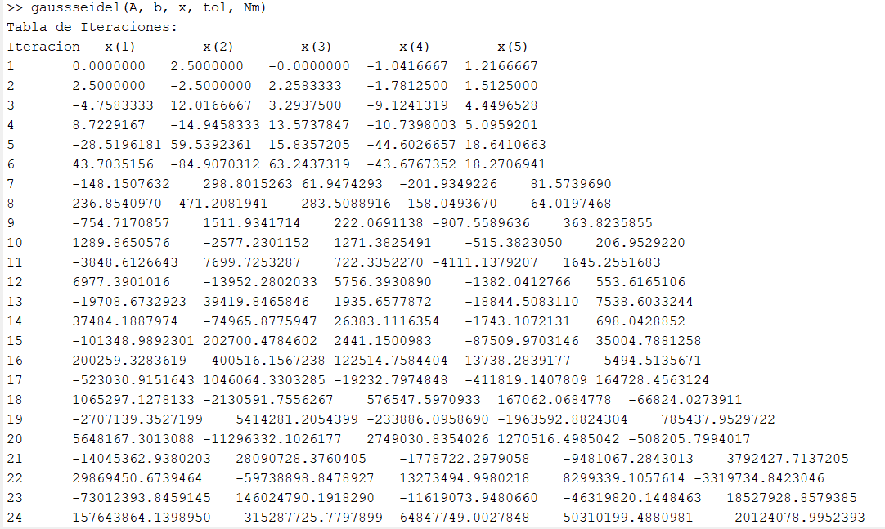

* **Cholesky**

By testing the provided matrix and vector with the Cholesky method, we can conclude that the system of equations was successfully solved but the results are not valid. the Cholesky method is also a matrix factorization method used to solve linear equation systems with symmetric positive definite matrices. In this method, the matrix is decomposed into the product of a lower triangular matrix and its conjugate transpose. If the Cholesky method does not converge, it means that the matrix is not positive definite.

* **Doolittle**

The Doolittle method is a matrix factorization method used to solve linear equation systems with symmetric positive definite matrices. In this method, the matrix is decomposed into two triangular matrices, an upper triangular matrix and a lower triangular matrix, and the system is solved using successive substitutions. If the Doolittle method converges, it means that the matrix is symmetric positive definite. This results are valid.

* **Jacobi**

If the spectral radius is not less than 1 when running the Jacobi and Gauss-Seidel methods, it means that the iterations do not converge, and the methods cannot find a solution. Both iterative methods rely on the convergence of the spectral radius, which is the magnitude of the largest eigenvalue of the iteration matrix.

In the Jacobi method, the original matrix is decomposed into a diagonal matrix and two triangular matrices. Each iteration is calculated using the previous values of the unknowns. If the spectral radius is not less than 1, it means that the method cannot guarantee convergence, and the obtained solutions may oscillate or diverge.

* Total pivoting

the total pivoting method is a powerful technique for solving systems of linear equations, but there are situations where it may not work correctly due to matrix singularity, rounding errors, large differences in matrix values, or implementation issues. In such cases, alternative approaches may be required to solve the system of equations.

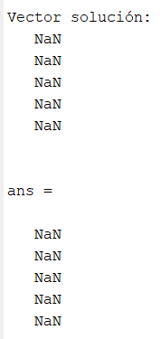

* Factorización LU

The LU factorization method is numerically stable, meaning it is less prone to rounding errors and error amplification compared to other numerical methods. This ensures a more accurate and reliable solution to the system of equations. LU factorization can be performed once and then used to solve multiple systems of equations with the same coefficient matrix A. This saves computational time, as the factorization is only done once, and subsequent solutions are obtained by solving triangular systems.

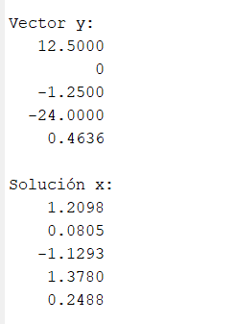

* Eliminacion Gaussiana

Simple Gaussian elimination method can be considered successful in solving this system of linear equations. However, it is important to note that in certain cases, such as systems with linearly dependent equations or ill-conditioned systems, the method may not be suitable or may encounter numerical difficulties.

